A000-Afr-Egyptian-Queen Tiye-Dynasty 18, ca.1355

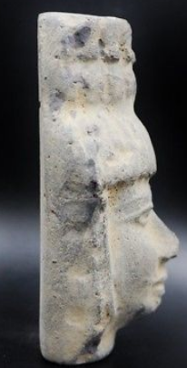 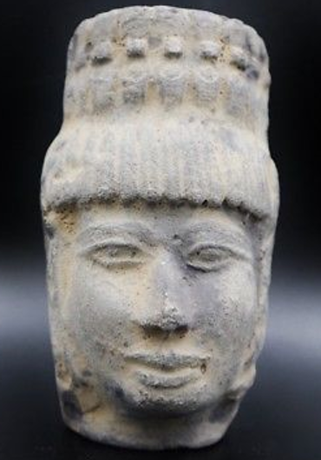 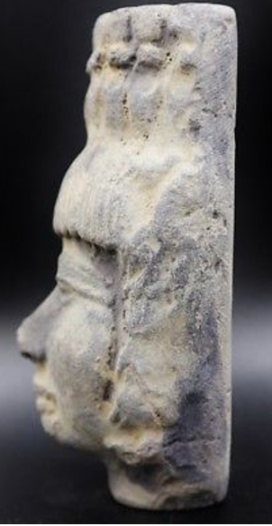

12.5 x 7 x 6 cm   (5" x 2.75" x 2.4" Inches).

+ 375 grams in weight.

**Case No.: 2**

**Accession No.**

**Formal Label:** Egyptian Queen Tiye-Terracotta-Dynasty 18-ca.1355

**Display Description:**

Queen Tiye  (c 1400 BCE Ipu, Egypt—c 1340), one of the most illustrious queens of ancient Egypt. She was the daughter of Yuya, a non-royal, wealthy landowner from the Upper Egyptian town of [Akhmin](https://en.wikipedia.org/wiki/Akhmin" \o "Akhmin) and the commander of the Egyptian chariotry and overseer of the cattle of the god Min; Tiye's mother, [Thuya](https://en.wikipedia.org/wiki/Thuya" \o "Thuya), was involved in religious cults (Singer of Hathor, Chief of the Entertainers of both [Amun](https://en.wikipedia.org/wiki/Amun" \o "Amun) and [Min](https://en.wikipedia.org/wiki/Min_(god))) which suggests that she was a member of the royal family.

She became the Great Royal Wife of the Egyptian pharaoh Amenhotep III. She was the mother of Akhenaten and grandmother of Tutankhamun. Her mummy was identified as "The Elder Lady" found in the tomb of Amenhotep II (KV35) in 2010 (Dodson 2010: 27-29).

through her. She continued to play an active role in foreign relations and was the first Egyptian queen to have her name recorded on official acts (Tyldesley 2006:118.).

**Accession Number:**

**LC Classification:**

**Date or Time Horizon:** Dynasty 18, ca.1355

**Geographical Area:** Amarna

**Map:**

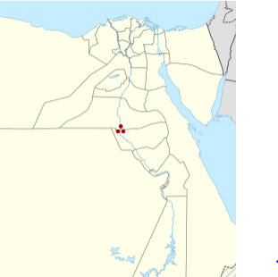

**Location d El Amarna, Egypy after https://upload.wikimedia.org/wikipedia/commons/thumb/e/e7/Egypt_adm_location_map.svg/375px-Egypt_adm_location_map.svg.png**

**GPS coordinates:** [27°38′42.71″N30°53′47.34″E](https://tools.wmflabs.org/geohack/geohack.php?pagename=Amarna&params=27_38_42.71_N_30_53_47.34_E_type:landmark)

**Cultural Affiliation:** New Kingdom, Egypt

**Medium:** terracotta

**Dimensions:** 12.5 x 7 x 6 cm   (5" x 2.75" x 2.4" Inches).

**Weight:** 375 grams

**Condition: original**

**Provenance:**

**Discussion:**

Since the royal women of Ancient Egypt carried the royal lineage, marriage to one could be a path to the throne for their progeny. Tiye became her husband’s trusted adviser and confidant. Being wise, intelligent, strong, and fierce, she was able to gain the respect of foreign dignitaries. Foreign leaders were willing to deal directly

**References:**

Dodson, Aidan. 2010. *Amarna Sunset: Nefertiti, Tutankhamun, Ay, Horemhab and the Egyptian Counter-reformation*. Cairo: AUC Press.

Kemp, B. & Garfi, S.. 1993. *A survey of the Ancient City of El-‘Amarna*. London: Egypt Exploration Society Occasional Publications 9.

Tyldesley, Joyce. 2006. *Chronicle of the Queens of Egypt*. London: Thames & Hudson.